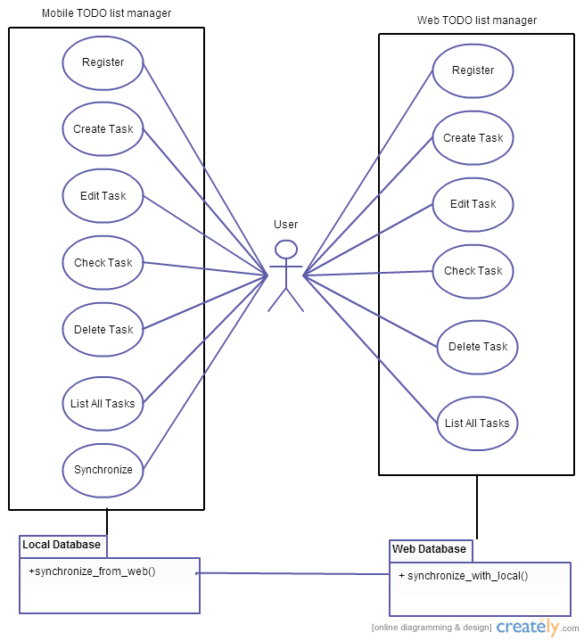

Scenarios:

Register:

User is on Login screen, click on register.

User is prompted for username, password and email. User input information and click on OK.

Client validate inputs with database.

If inputs are valid, create new user and return to the login screen.

If not valid, warn the user and stay on Register screen.

Login:

User is on Login screen, input username and password, click login

LoginActivity compares the input with database through TaskDatabase

User is logged in

TaskListActivity queries user tasks from database through TaskDatabase

User is displayed his task list

Traceability:

Input username/password validated through TaskDatabase

User data pulled from TaskDatabase

User Class created

TaskListActivity opens a Task List for a successful login

UI Display show the Task List for the specified user

Edit:

User is on task list screen, select task and click edit

EditTaskActivity pulls task information from database through TaskDatabase

User is displayed the edit task screen

User change task information

EditTaskActivity validates the input

If input invalid provide a warning

If input validated, save task to the database and return the user to the tasklist.

Traceability:

Edit starts on the TaskListActivity sending parameters

Edit view (UI) modes

Item edit modes get sent to the database when user leaves Activity

Add/Delete:

User is on task list screen, click on add

User is shown the edit task screen with no data

User input task information

EditTaskActivity validates the input

If input invalid provide a warning

If input validated, save task to the database and return the user to the tasklist.

User should be able to delete tasks. Deleted Tasks should be removed from tasklist and the data should be deleted from database.

Traceability:

Add/Delete starts on the TaskListActivity sending parameters

add view (UI) modes

Item added/deleted modes get sent to the database when user leaves Activity

Check/Checkoff:

User is on tasklist screen, click on the checkbox in front of a task

TaskListActivity save the status of that task to the database and refresh the task list screen

Updated task list is displayed to the user.

Show/hide checked-off Items:

User is on tasklist screen, click on show/hide button

Show/hide checked-off tasks in the tasklist page.

Synchronize:

User is logged in on Mobile client, and click synchronize.

Mobile client connect to web server and synchronize data on both sides.

User is displayed a message when the work is completed.